Name:- Nilesh Raj
Gmail:- nileshraji811001@gamil.com

Exercise 2: E-commerce Platform Search Function
Scenario:
You are working on the search functionality of an e-commerce platform. The search needs to be optimized for fast performance.
1.Product Class
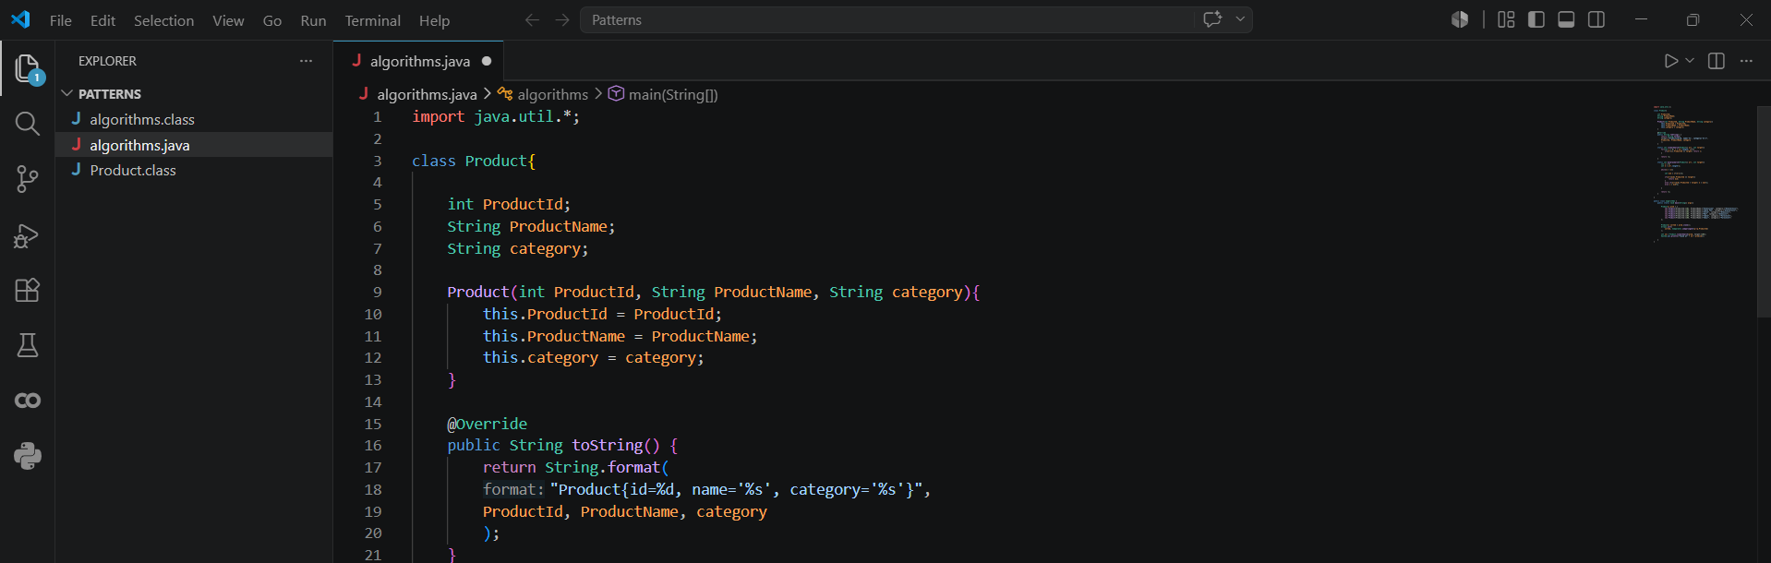
2. Searching Functions
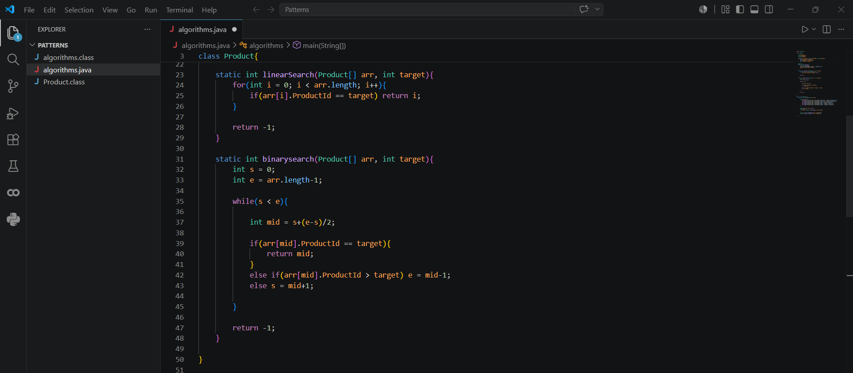

3. Main Function
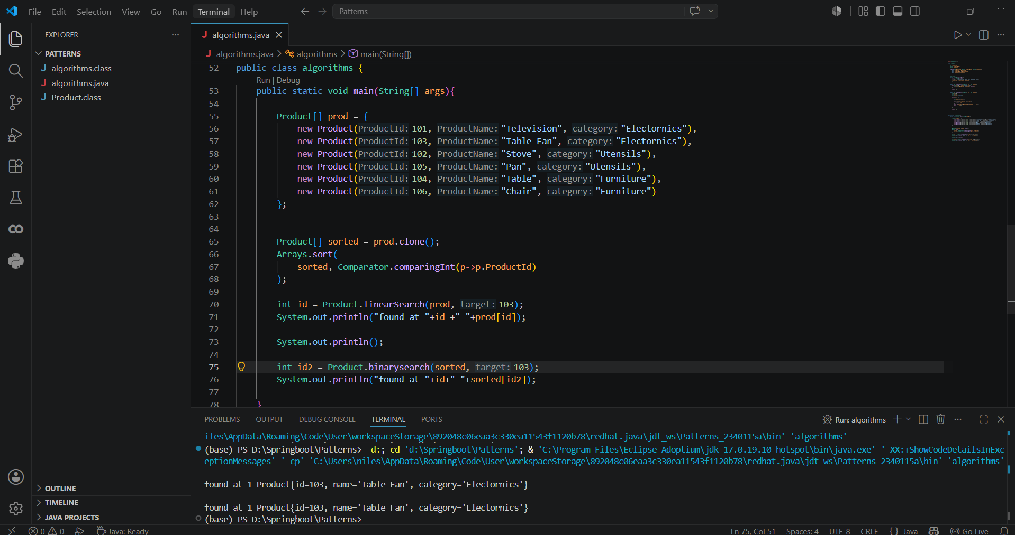

Exercise 7: Financial Forecasting
Scenario:
You are developing a financial forecasting tool that predicts future values based on past data.
1.Using Recursive Algorithm
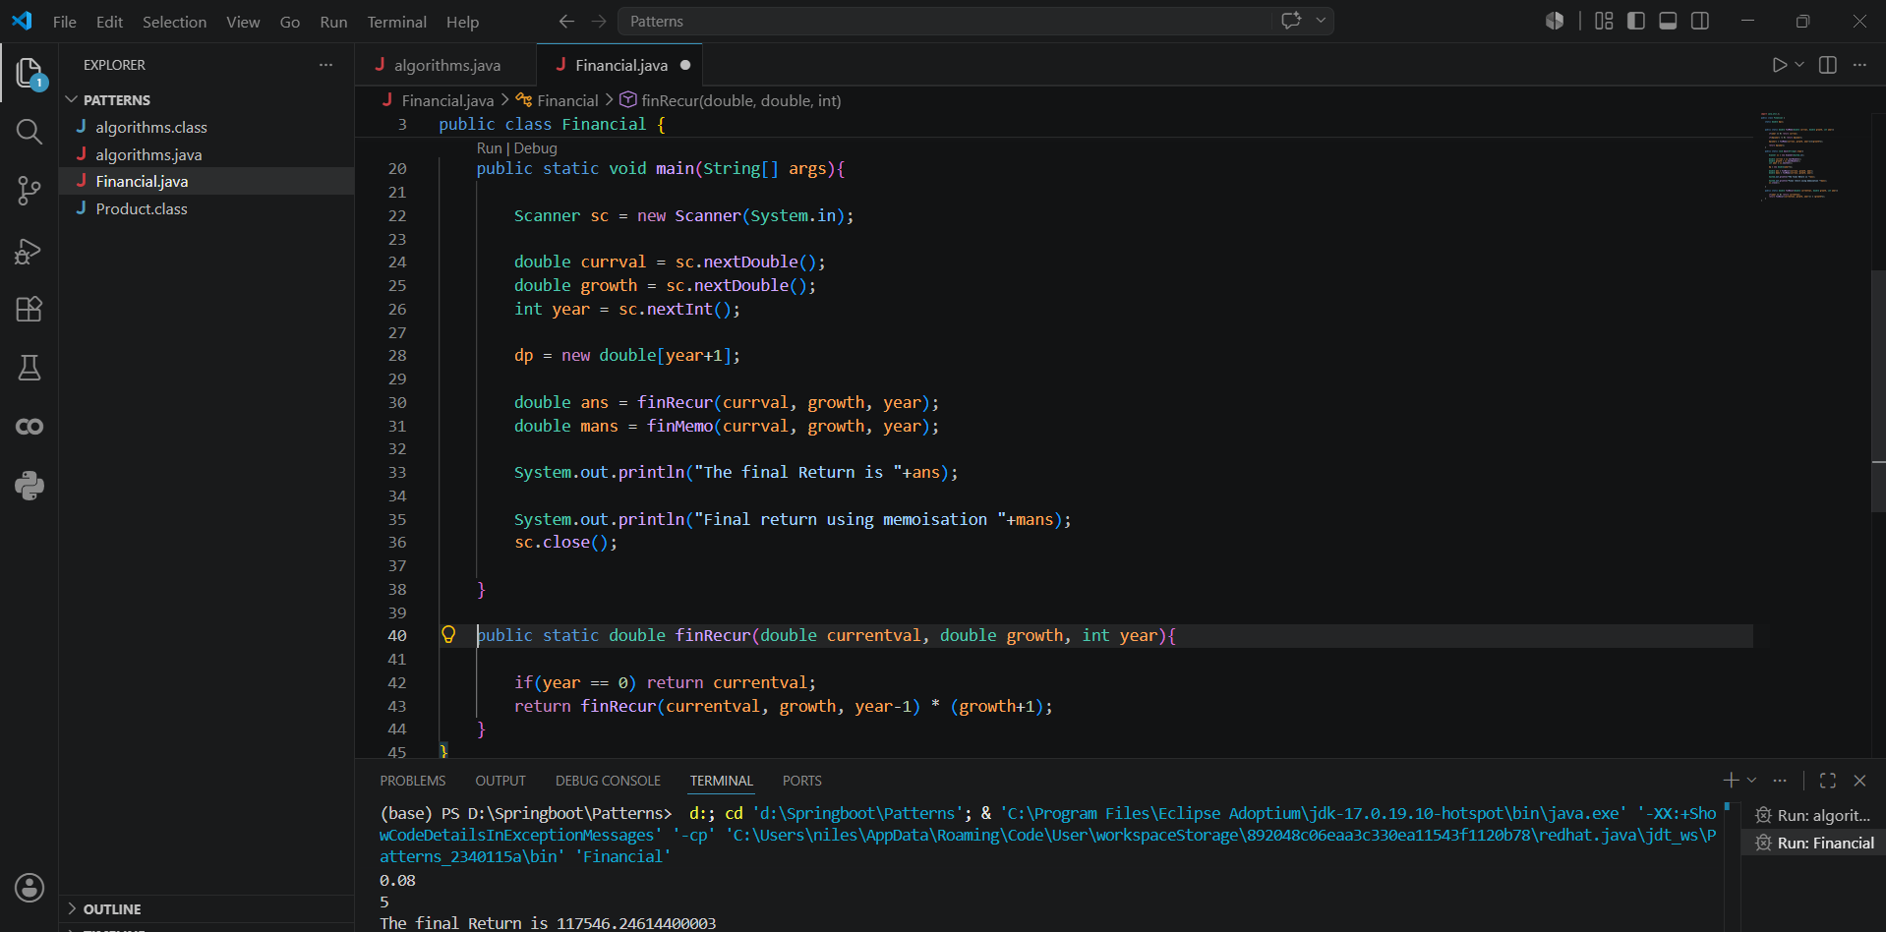

2. Using Memoisation (Optimized)
